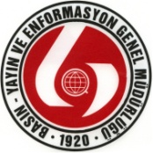 | Republic of Turkey  Office of the Prime Minister  Directorate General of Press and Information  Head of Information Department | 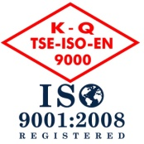

TURKEY-AFGHANISTAN-PAKISTAN 7th TRILATERAL SUMMIT
(December 11-12, 2012 - Ankara, TURKEY)

PRESS ACCREDITATION FORM

Name, Surname

Date of Birth-Day/Month/Year |  | Place of Birth | Place of Birth
Nationality |  |  |  | Sex: Male |  | Female
Passport Number

Press organization’s:

Name

Country

Address
Phone |  | Place of Birth | Fax
GSM |  |  | E-mail

Newspaper TV Station Magazine
Radio Station News Agency Other ___________________

Position

Correspondent Cameraman Technician
Commentator Photographer Other ___________________

Signature _________________________ Date: ....../....../2012

